Module Name: Defect Identification & Bug Report
Test Case ID: 5
Webpage URL: https://www.saucedemo.com/

Scenario ID: 1

Scenario: Valid login
Test Steps:
1. Open the website
2. Enter username
3. Enter password
4. Click Login button

Screenshots:

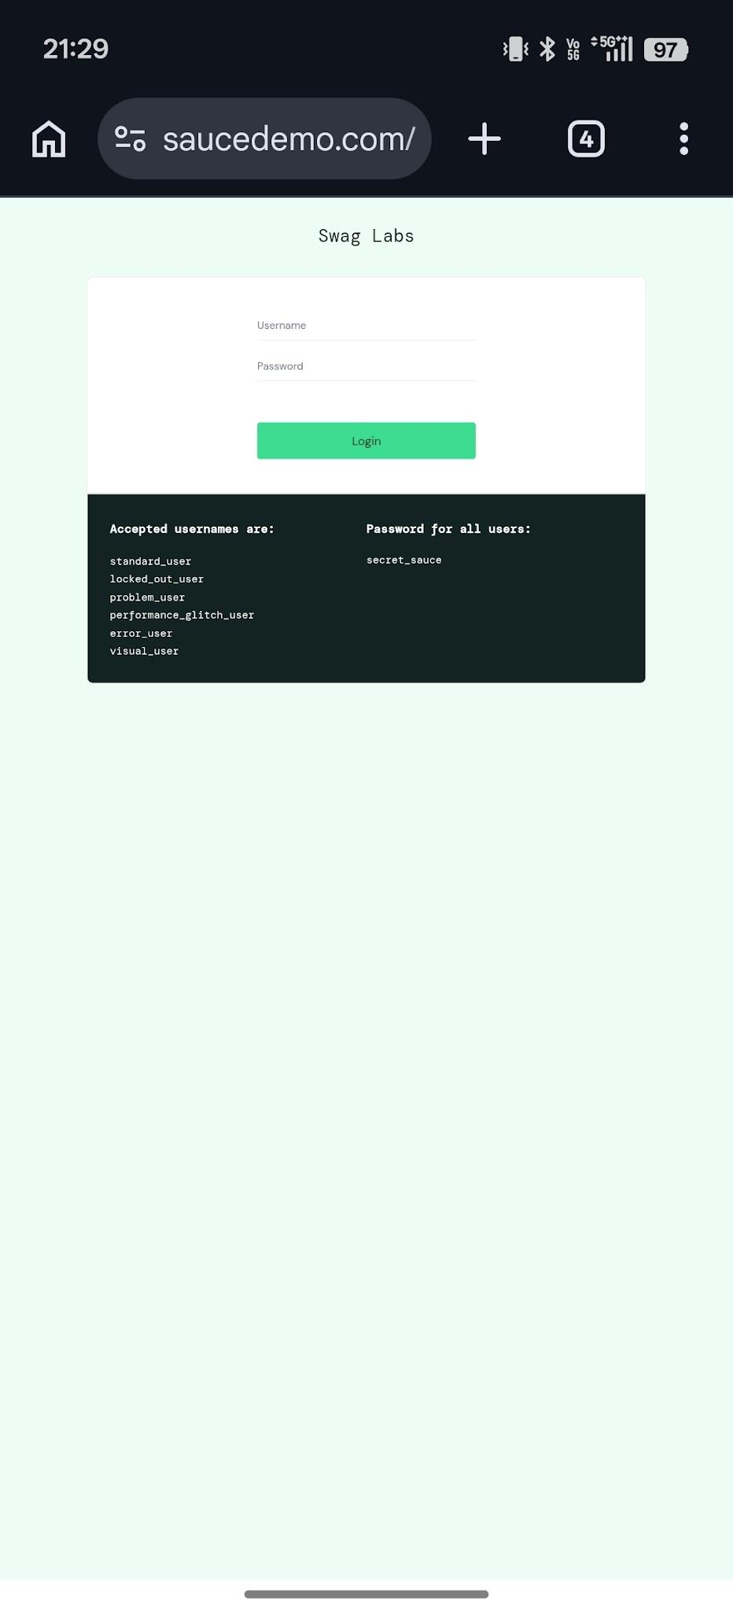

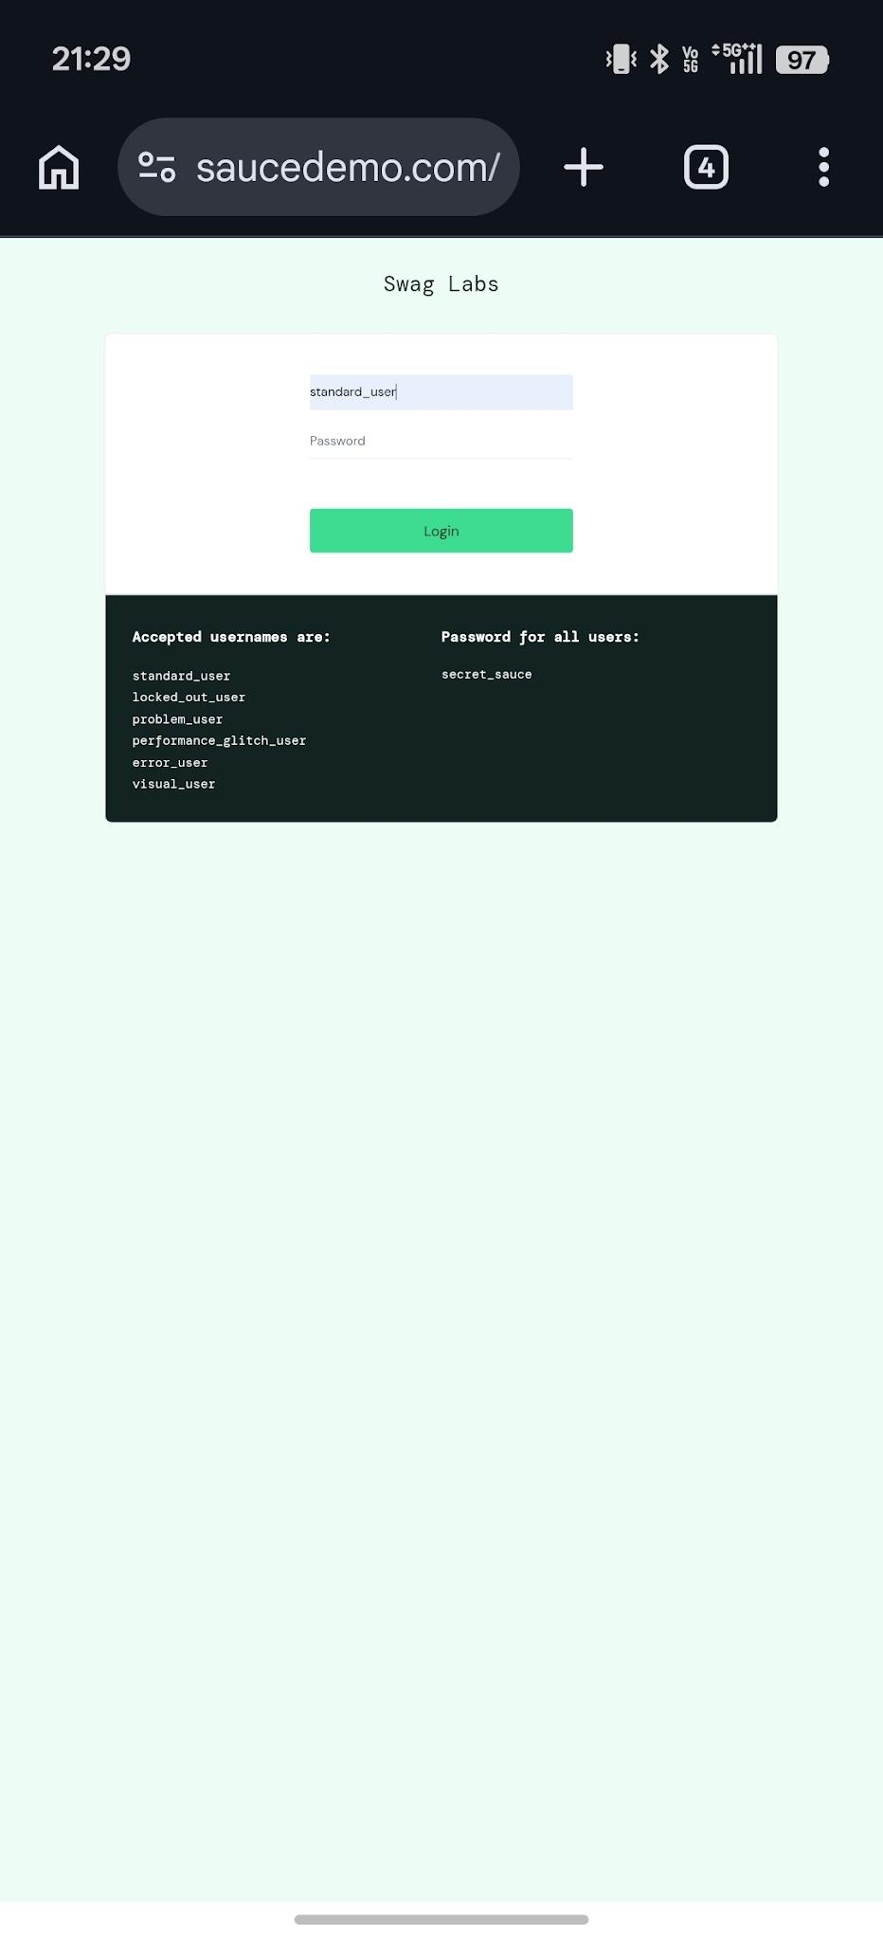

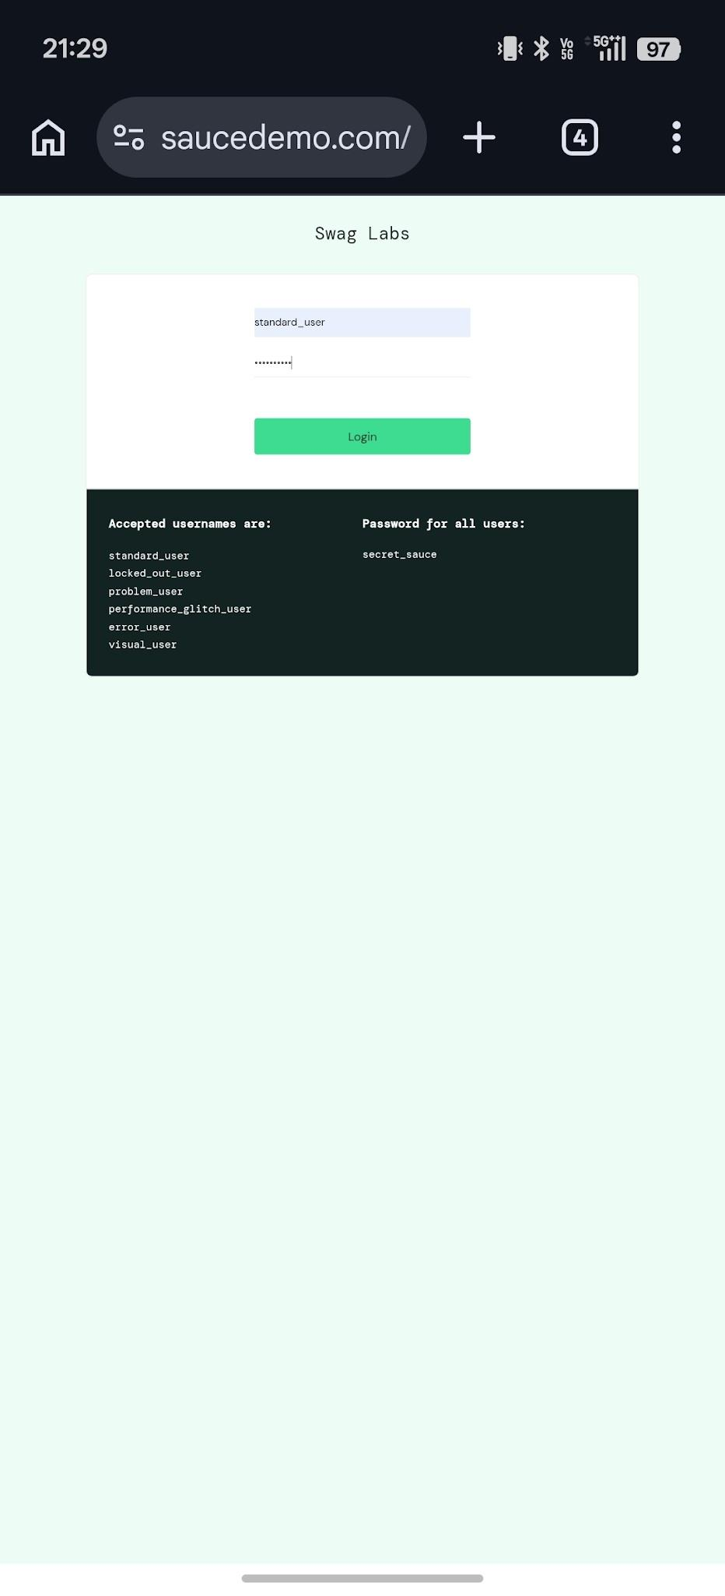

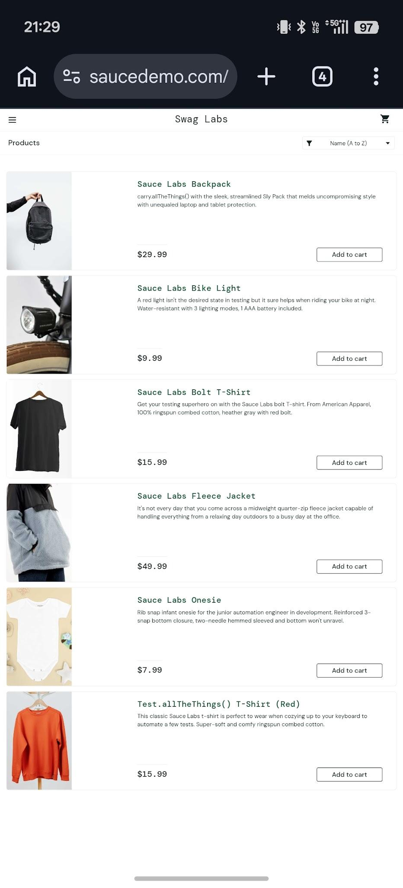

Scenario ID: 2

Scenario: Invalid login
Test Steps:
1. Open the website
2. Enter invalid username
3. Enter invalid password
4. Click Login button

Screenshots:

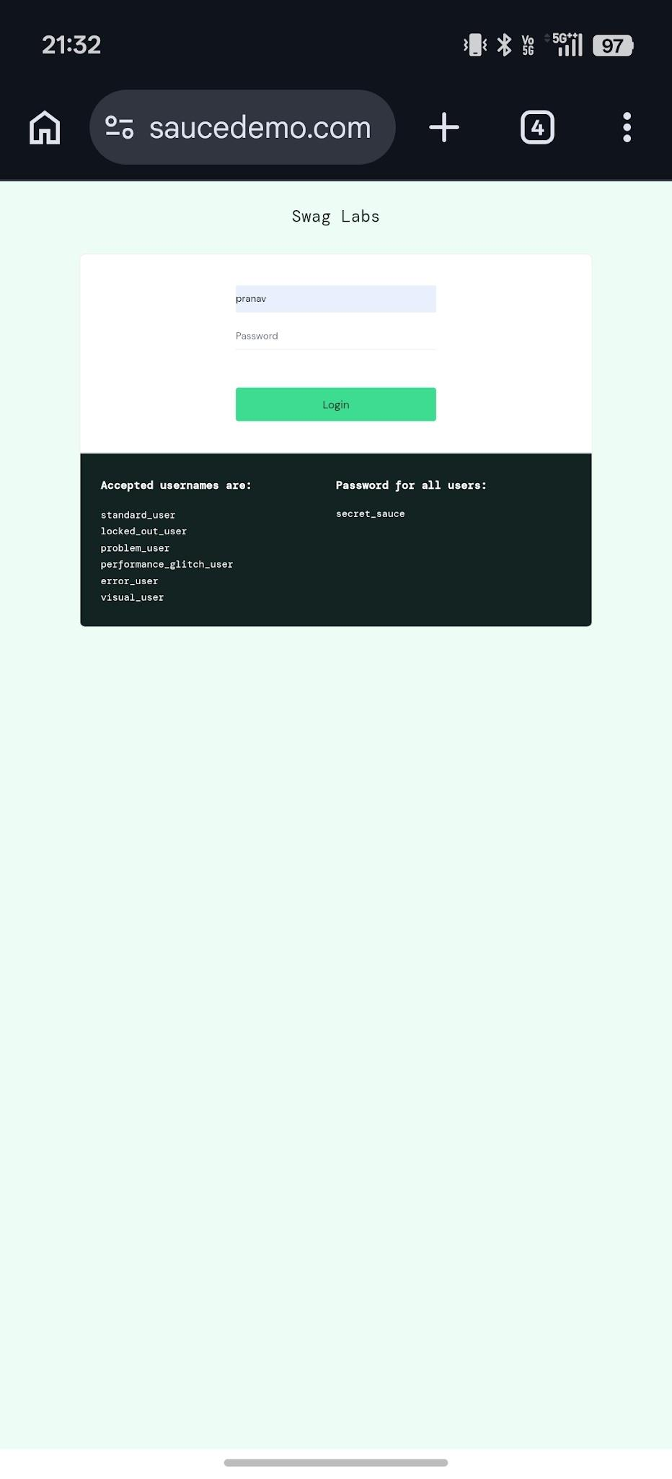

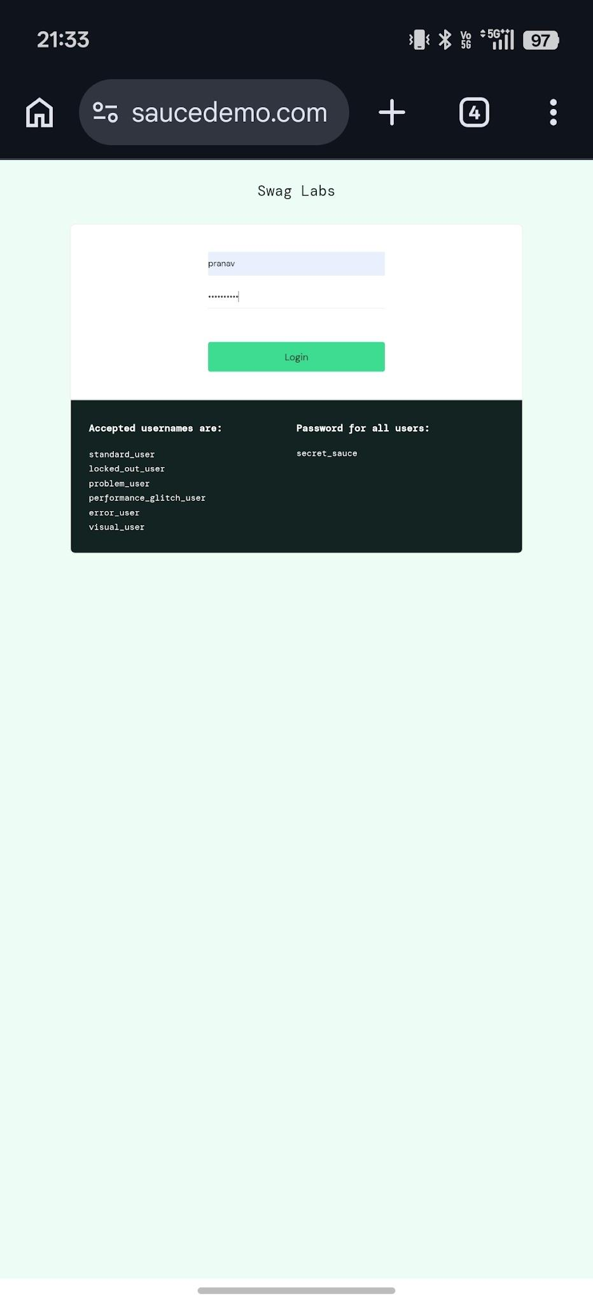

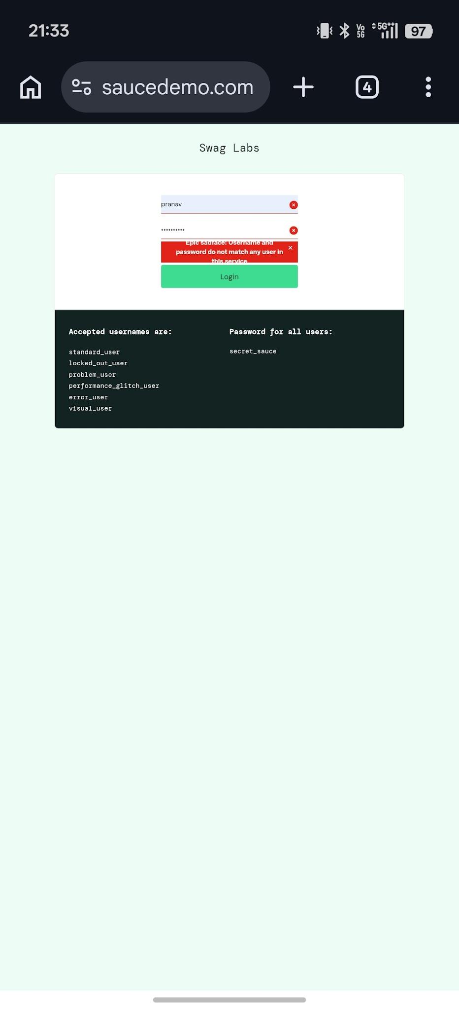

Scenario ID: 3

Scenario: Product display
Test Steps:
1. tap the product and it will show the display

Screenshots:

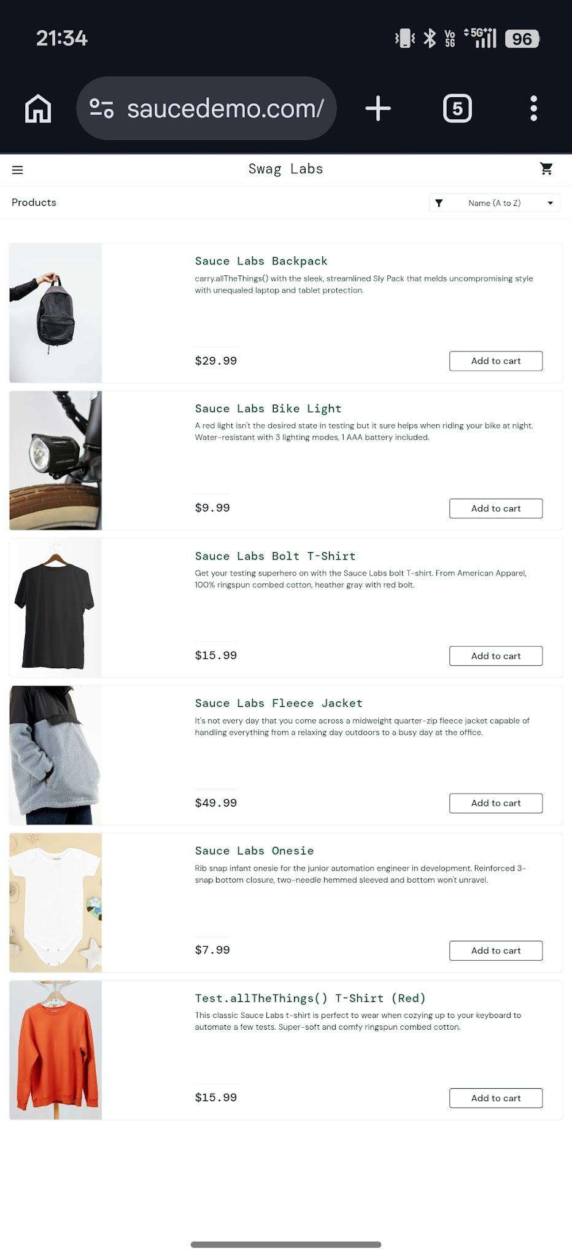

Scenario ID: 4

Scenario: Add to cart
Test Steps:
1. Click on Cart icon

Screenshots:

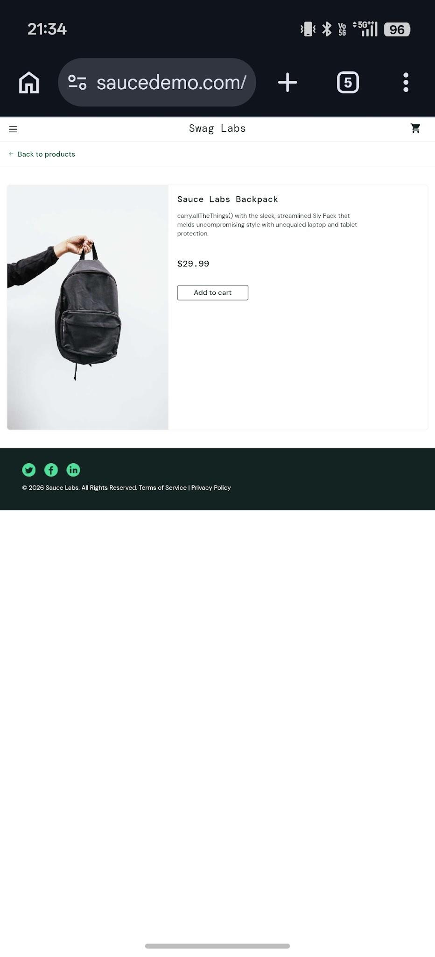

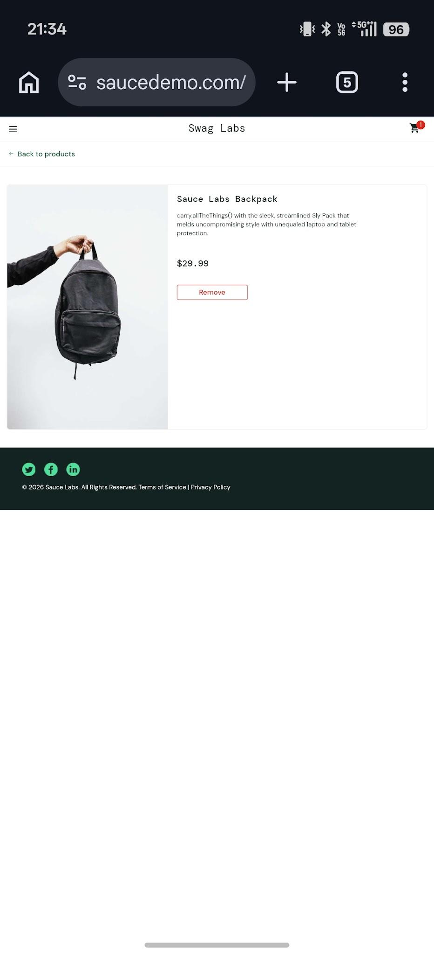

Scenario ID: 5

Scenario: Remove from cart
Test Steps:
1. Click on remove option

Screenshots:

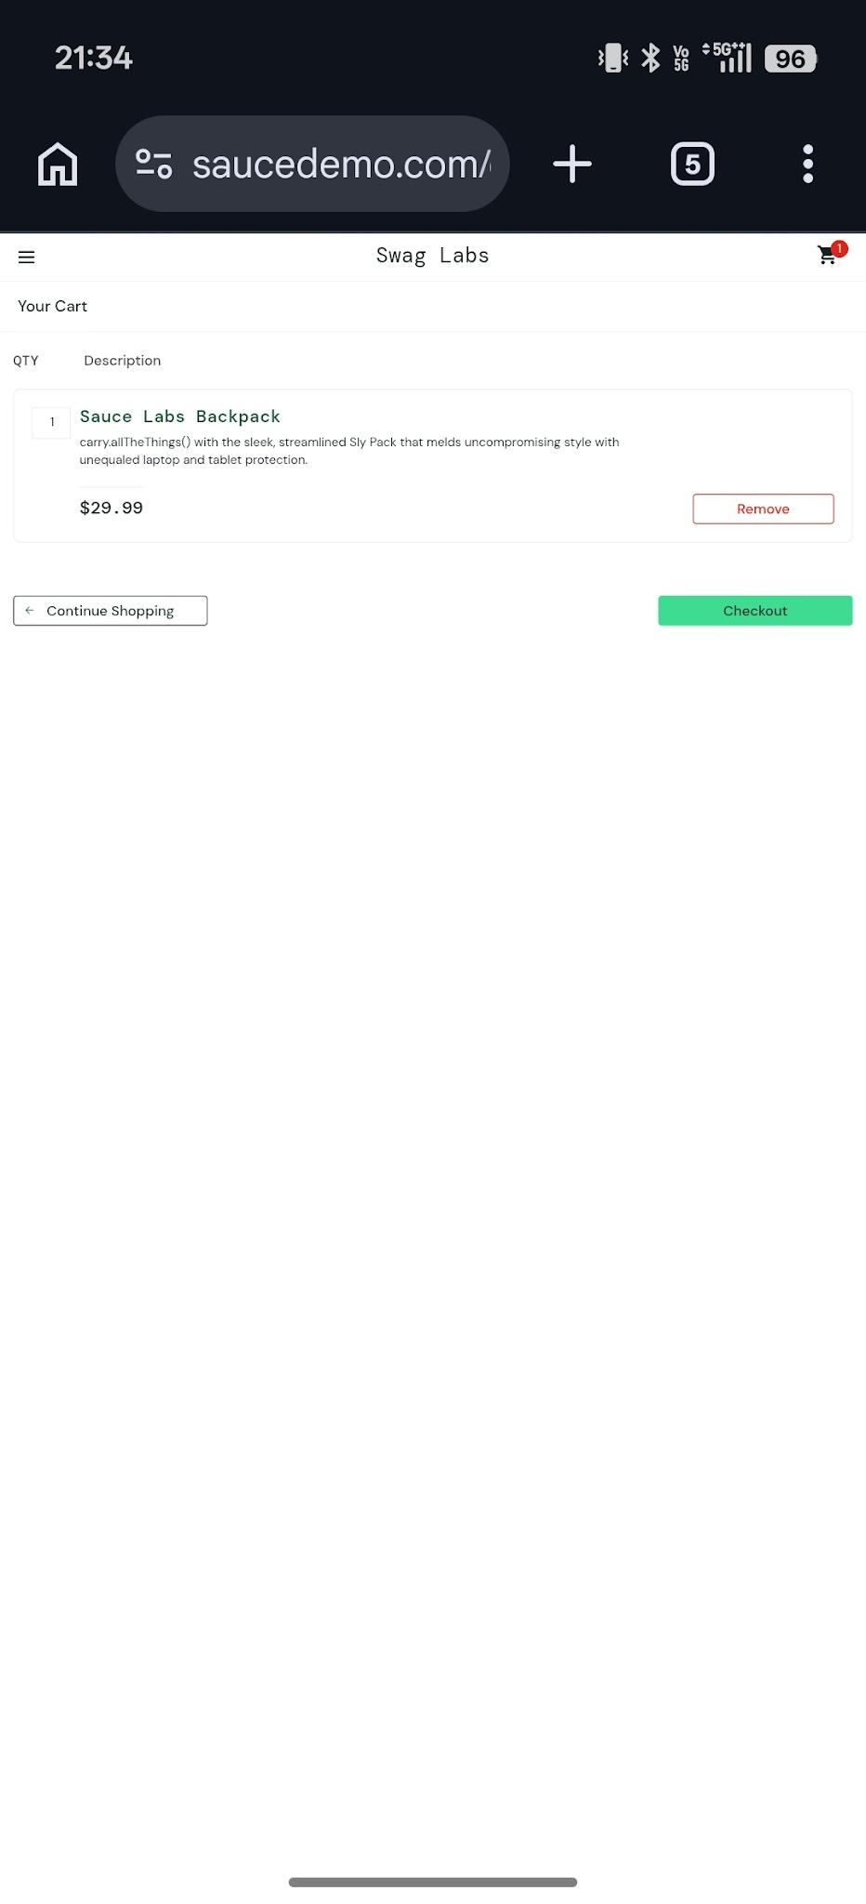

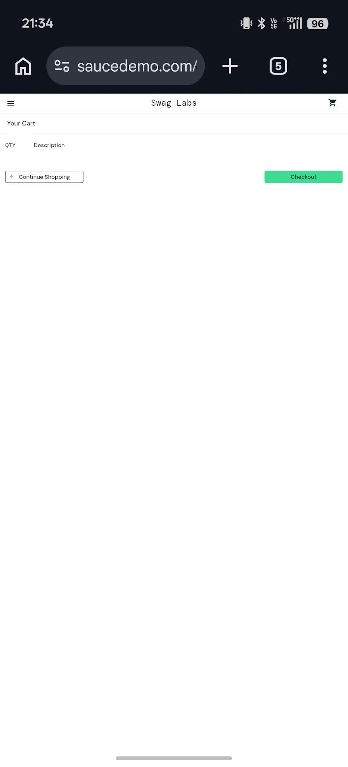

Scenario ID: 6

Scenario: cart
Test Steps:
1. click on Cart

Screenshots:

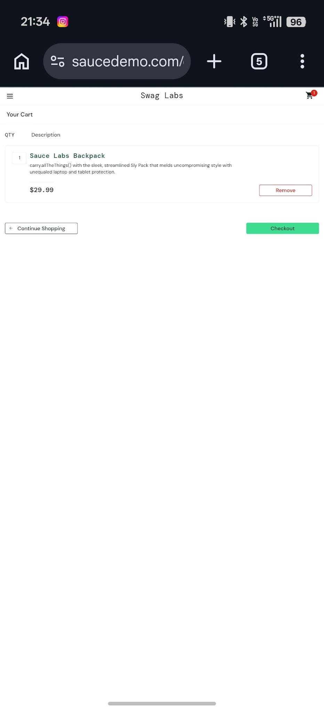

Scenario ID: 7

Scenario: checkout
Test Steps:
1. Tap on checkout
2. Enter first name
3. Enter second name
4. Enter pincode

Screenshots:

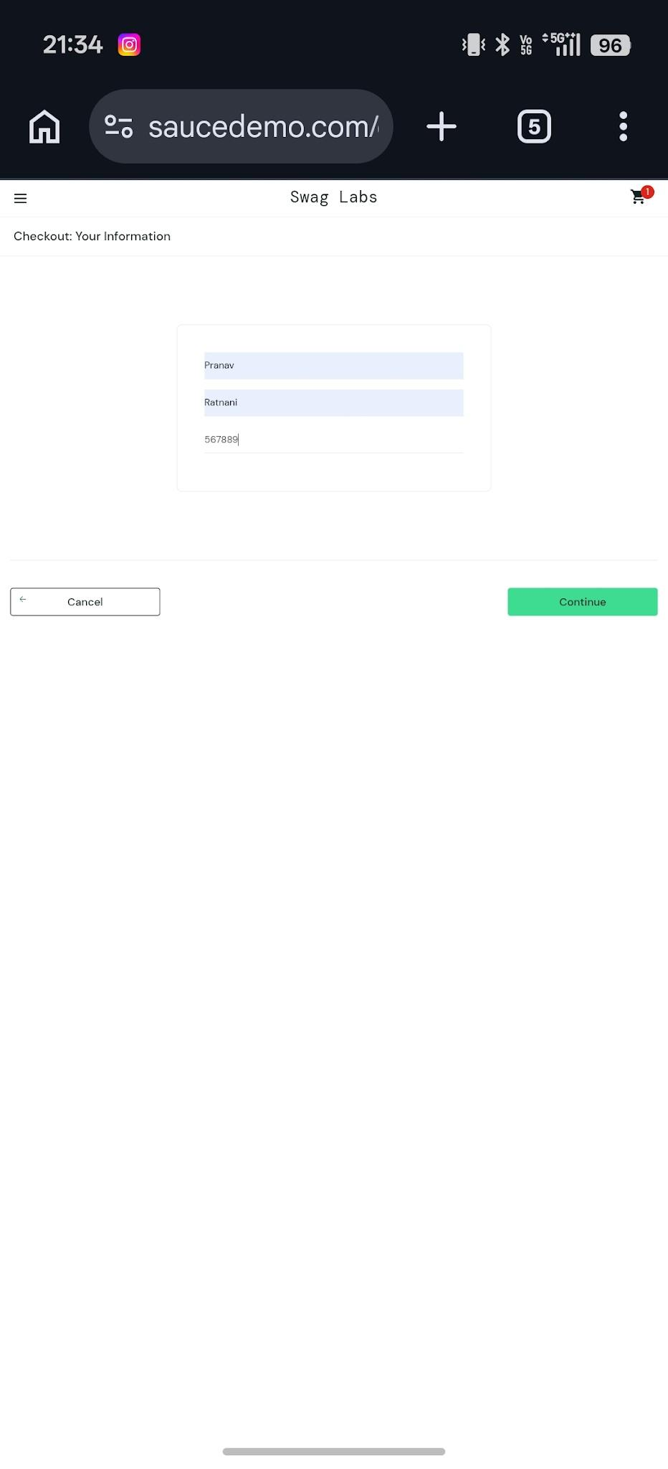

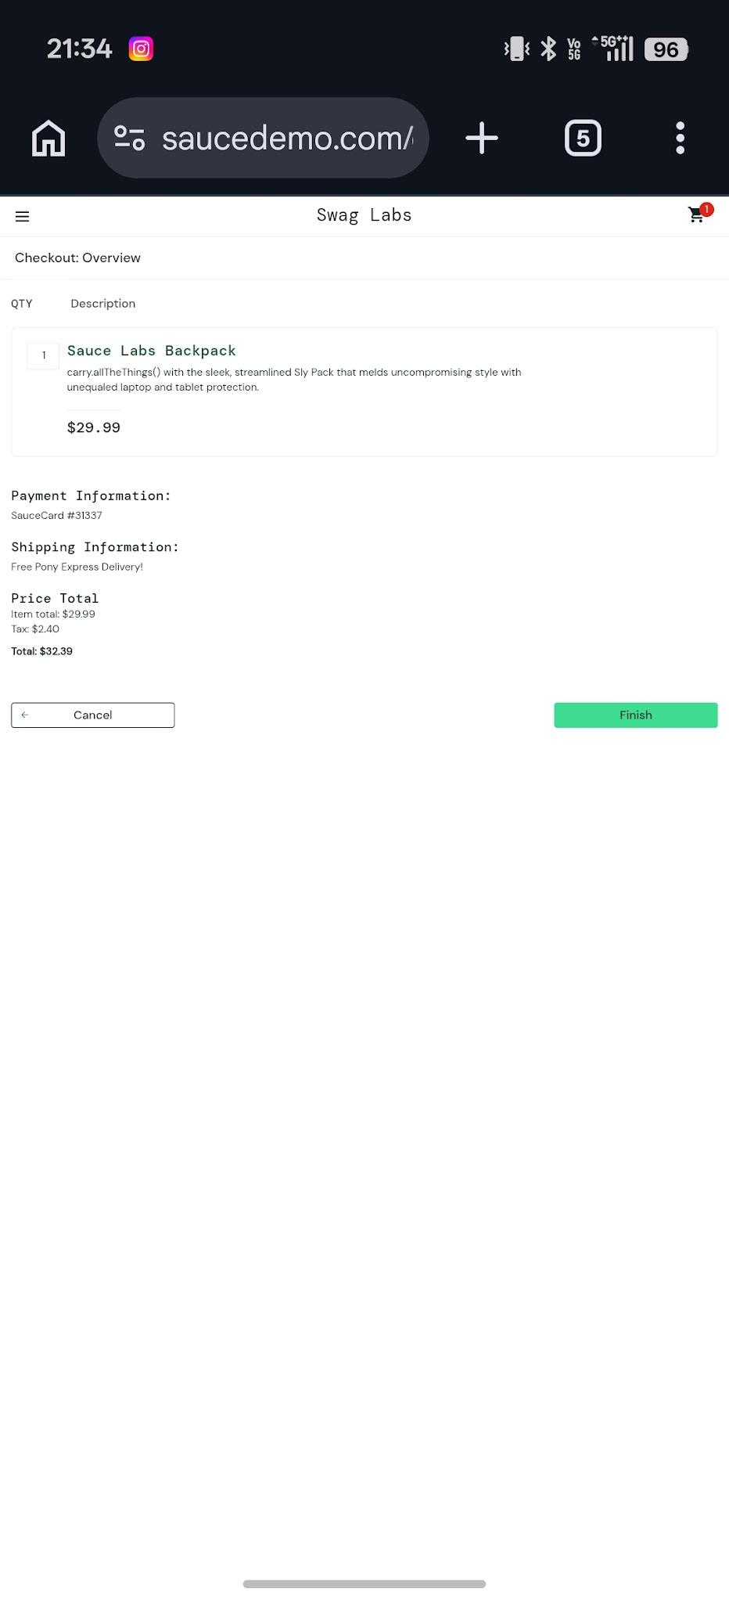

Scenario ID: 7

Scenario: logout
Test Steps:
1.Click on logout icon

Screenshots:

